# Game Two – Mountain Of The Martyr – Outline

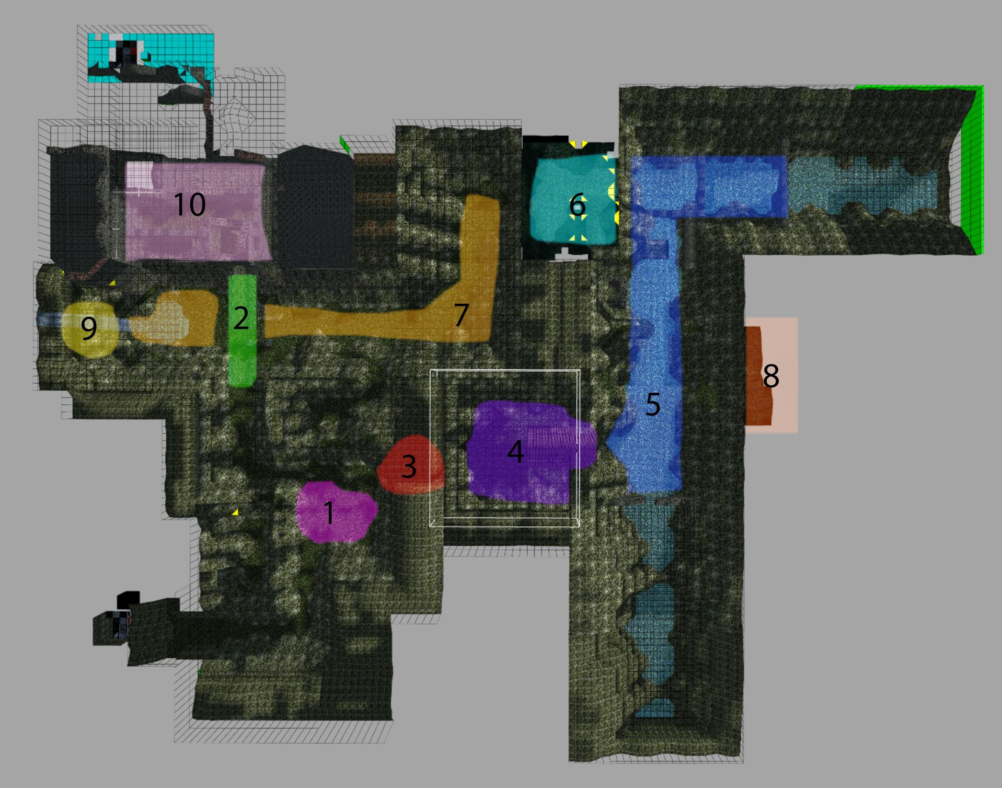

## General overview

* The level takes place in a mountainous area of German-Czech border. The entire location is filled with multiple hills, valleys and rivers all overgrown by nature. The atmosphere is a mix between greyish style of The Witcher (2008) and lush natural environment of The Elder Scrolls: Skyrim.
* The idea is to provide a level that is a good introduction to the game’s mechanics and more cinematic experience. It will be the easiest and the lightest in style/art direction of all the levels. Both Mountain of the Martyr and Castle Kriegler will work as a smooth transition between the light feeling of the classics and a darker, more gruesome experience of The Dark Renaissance.
* Lara’s main goal here is to find a way to get inside the Castle. The Castle itself can be seen from the very beginning, but Lara will have to find a cunning way in order to get access to the entrance, since the bridge is destroyed.

## Important locations

1. **The Dead Tree** - the first location Lara gets to. It is basically a forested area with a big, dead tree in the centre. It is there where Lara finds a **stick** that she will use to create a **torch**.
2. **The Bridge** – the bridge is the only way to enter the Castle. It can be accessed right from the beginning of the game, but falls apart when Lara steps on it.
3. **The Wolves Cave** - a cave that connects **the Dead Tree** area with **The Chapel**. She finds a key there which opens path to **the Castle Valley**.
4. **The Chapel** – it is a small, XVIth century building constructed in late gothic style. It is surrounded by a cemetery. Inside there will be a puzzle, which once solved will give access to the tomb beneath the chapel.
5. **The River Valley** – This huge area will mainly consist of platforming sequences and will work as an introduction to Krystian’s freeform climbing system. There will be also a puzzle with a **broken dam**, which, once restored, will slow down water rapids and allow Lara to either access or exit the **big cave** area.
6. **The Cave** is basically a connection between the River Valley and the Castle Valley.
7. **The Castle Valley** is the main valley that connects both ends of the level. On its side there are ruins of the Castle Kriegler, that Lara will have to access. This area will consist of platforming sequences and small caves, where Lara finds necessary equipment to get to the castle.
8. **The Dam Puzzle** - this is where the machinery to control the dam is. Lara will have to fix it in order to move forward.
9. **Watermill** - this will be a huge tower with the device that when working, will fill the tower with water. Once it is filled Lara will be able to swim to the higher level and access the castle.
10. **The Castle Entrance** - the main goal of the level. Once Lara enters the gate to the castle the proper Castle Kriegler level will load.

## Main puzzles

* **The Lanterns** – this puzzle will become available once the Chapel itself is opened. Lara will have to light up two lanterns, then rotate them so all the people on the walls’ polychrome are illuminated by light. Once this is done the door to the dungeons opens where the switch to raise the grate is.
* **The Torch** - the first puzzle that Lara has to solve involves creating a torch to light up lanterns or burn bushes that block the way. For that she will need three things:
  + **Stick** - which she will break off of a dead tree in the first location.
  + **Cloth** - maybe she will find an old flag and use it for this purpose?
  + **Fire** - Lara will find an old camp in The Castle Valley, with an extinguished bonfire. Using a **lighter** she will ignite the bonfire, from which she will then light up the torch.
* **The Dam** - this puzzle will be placed in the River Valley section of the level. Lara will have to close the dam so she can get access to the Cave.
* **The Waterfall** - A grate is visible behind a
* **OBSOLETE:The waterfall** - A waterfall of deadly water is blocking the way to the iron grate behind which is the second entrance to the castle. Once the waterfall is gone Lara will have to enter **the Chapel** and light up lanterns in order to raise the grate.

## Gameplay flow

1. Lara starts on a path that is blocked by a wired fence on one side. She goes along the path and enters **the Dead Tree** area. A **shadow of a wolf** appears (+howling sound). Lara follows the shadow to **the Bridge** area.
2. Lara walks towards the bridge. The **CUTSCENE** appears where the bridge collapses. Lara has to run back to safety. Another **wolf shadow** appears, going back to **the Dead Tree** area.
3. Lara follows the shadow. She sees it again, this time hiding behind bushes. There is a **new path** opened that wasn’t available before. She enters a cave, where **wolves attack her.** She kills them all and then finds a decaying body of a man (a WWII soldier? A guard? A lost Lux Veritatis member? TBD).
4. **From this point the level becomes less linear. There are two possible ways to go.** She can either pass the **Wolves Cave** and enter the **Chapel** area OR she can return to the **Bridge** area and open the door to the **Castle Valley.**
5. **If player goes to the Castle Valley** he will see a grate behind the waterfall. The grate is down and the waterfall is blocking the way. If Lara touches the water, she dies.
6. **Objectives: She has to stop the water and raise the grate, but how?**
7. **To stop the water** Lara will have to